mission
EZE NICHOLAS IKECHUKWU
Safety Officer, Computer Science
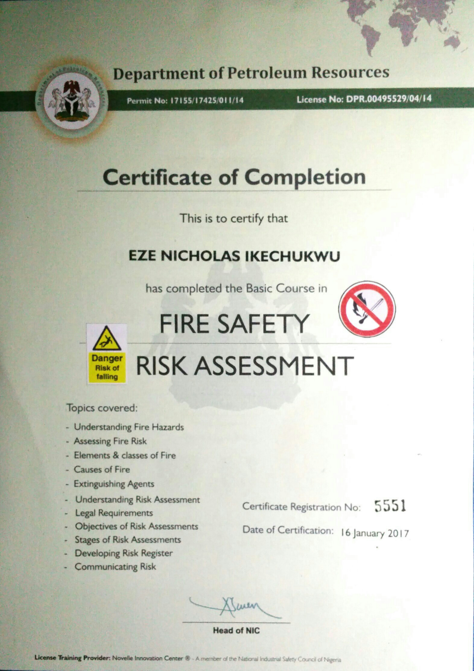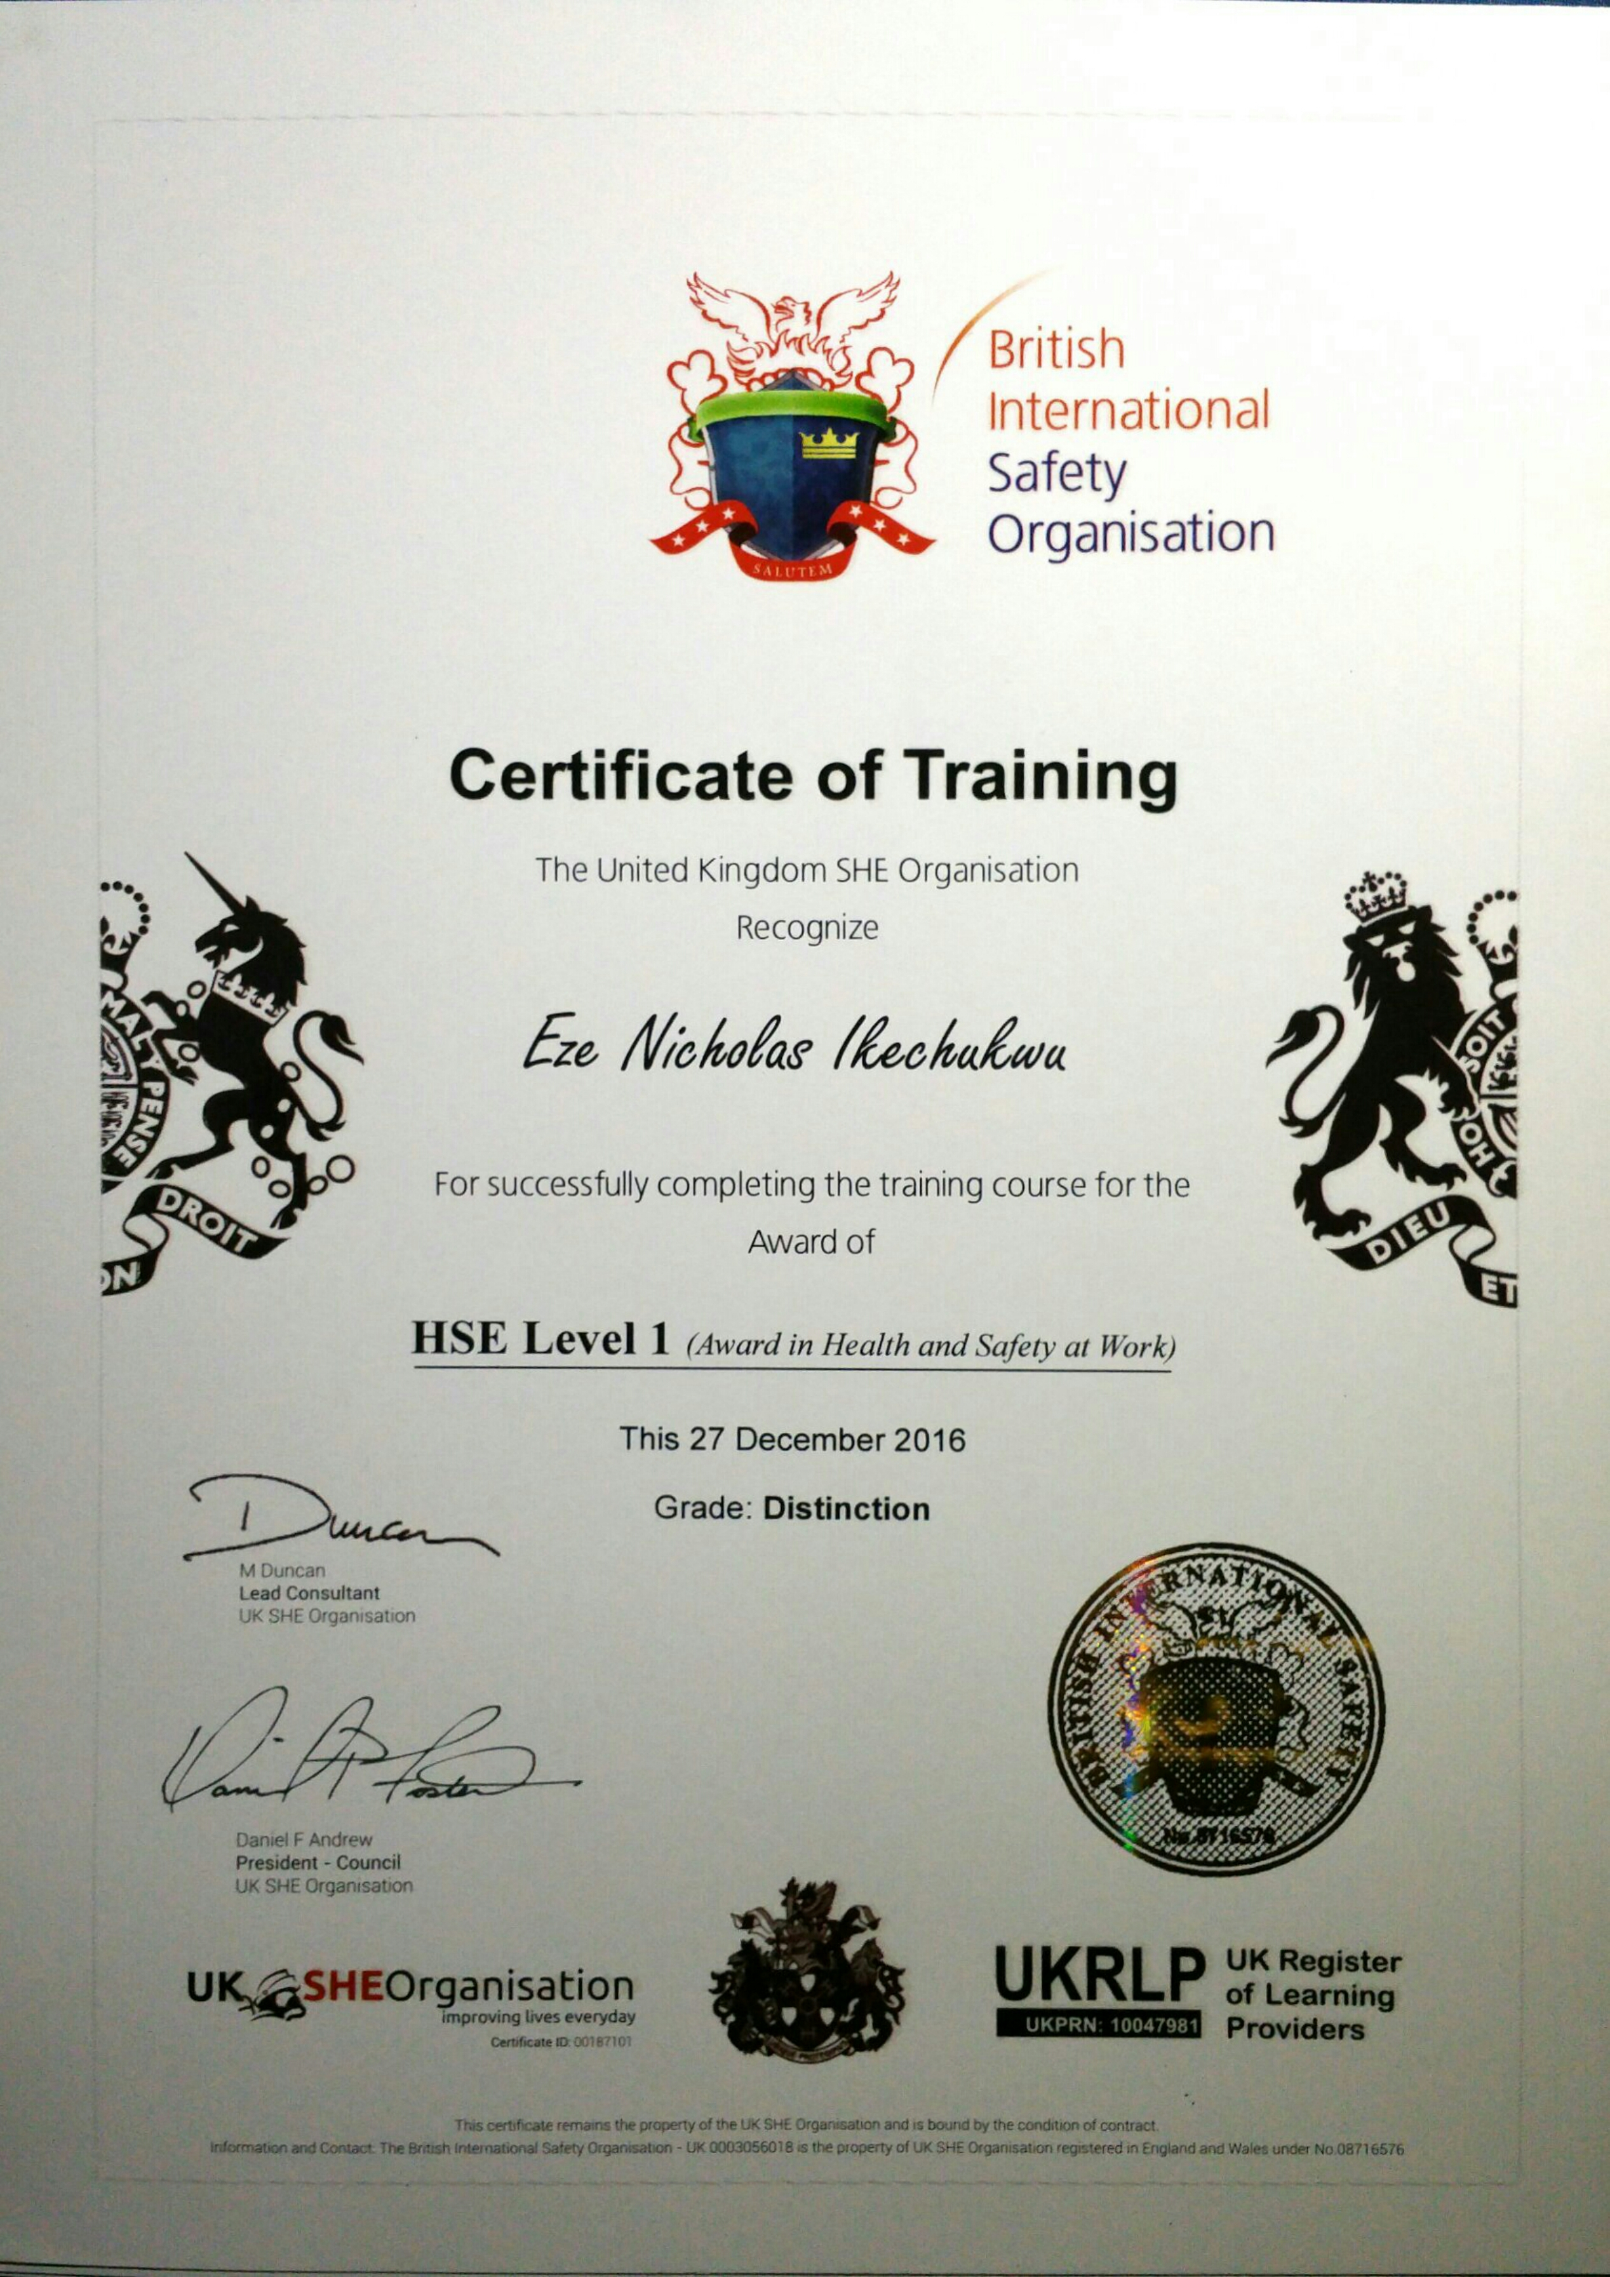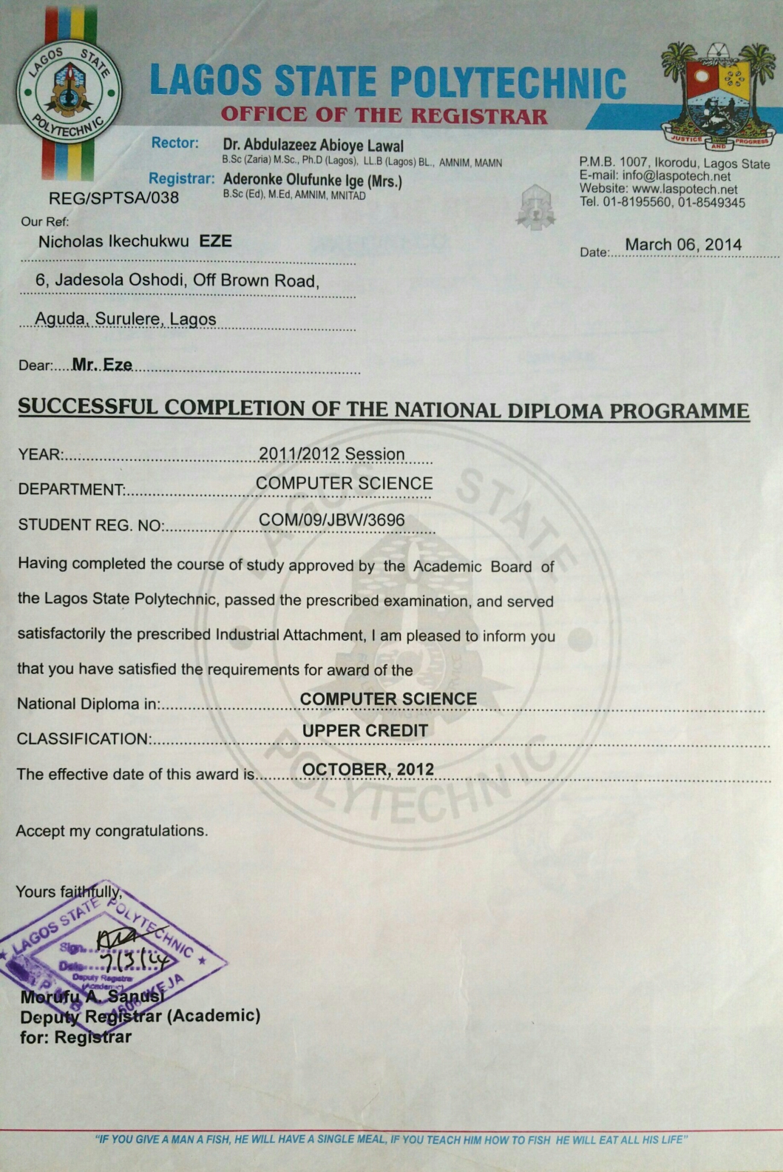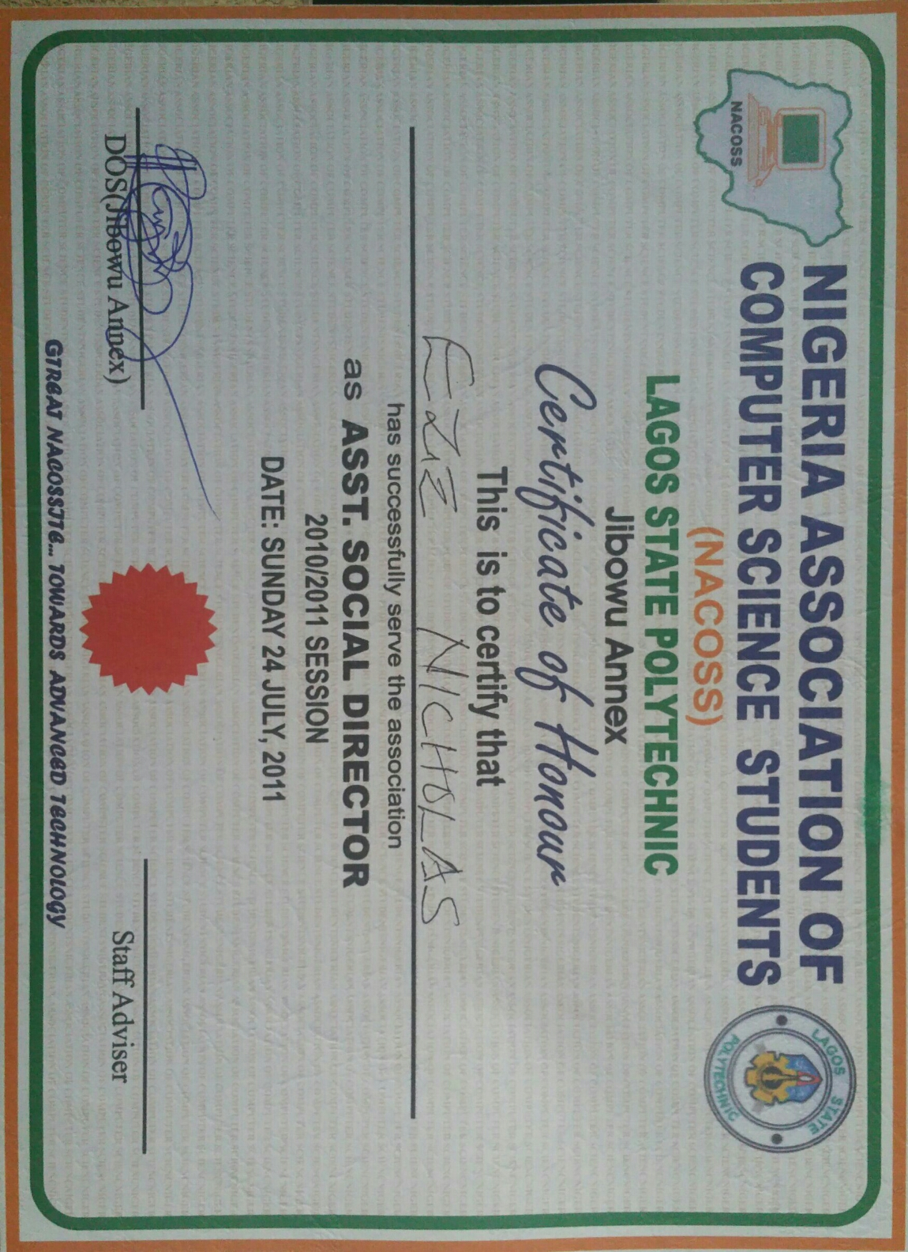
EDUCATION AND TRAINING
UK Health and Safety Executive (BISO) -2016
Lagos City poly - (HND, in view) – presently
Lagos State Poly – (ND, Comp Sc, Upper Credit) –2012
Marist Comp College, Ezzagu (WASSCE) – 2005
Gender: male
Language: English and Igbo
State: Enugu
Birth Day: September 3, 1985
Status: married
Phone: +2348063259540, 08126859255
Address: 9, Ola-Iya street, Ago, Okota, Lagos
Email: macnmine@gmail.com, macnmine@yahoo.com
I seek to drive excellence, professionalism and profitability within an organization in order to provide 100% plus solutions that deliver high commercial value in the marketplace.

EMPLOYMENT HISTORY
BRANCH MANAGER/SALES FEB.2015--2017
AJATECH COMPUTERS LIMITED
8, ALLI STREET, TINUBU SQUARE, LAGOS ISLAND
- To take full charge of the branch ensuring the proper and efficient management.
- To set sales goals and determine the best way to achieve them
- To ensure all transactions of the branch are properly recorded and follows process
- To ensure that the risk of bad debt is reduced by regular selling on cash basis and if sold on credit at all, effort is needed to collect them.
- Regular reporting of activities to both the managing director and the management

BUSINESS DEVELOPMENT EXECUTIVE 2014--JAN.2015
TROMVILLE INVESTMENT LIMITED,
25, SALVATION ROAD, OPEBI, IKEJA
- Ensuring that strategy and commercial aims are totally aligned with its goals
- Winning major clients accounts
- Supporting and advising junior members of staff.
- Making high member of daily outbound to prospective new clients
- Reviewing customer feedback and then suggesting ways to improve processes and services levels.
MARKETING EXECUTIVE MARCH, 2013—2014
LEADWAY ASSURANCE COMPANY LIMITED
4th FLOOR, AKURO HOUSE, 24 CAMPBELL STREET, LAGOS ISLAND
- Rendering a substantial service to our present and prospective clients
- Operating in an ever-growing marketing where millions of insurance sales are made.
- Sharing flyers to people willing to partner, or insure their property with the company.
- Identify and attend tradeshows and other business functions to keep abreast of developments in the market place, to find potential new business.

personal portfolio
Personal Attributes
- Able to learn quickly, think critically and work independently on any issue in order to arrive at a workable and most profitable course of action.
- Strong teamwork, negotiation and leadership qualities, coupled with proven excellence in oral and written communication.
TECHNICAL SKILLS
- Microsoft Office (MSWord, PowerPoint, Excel, Publisher, Access)
- Presentation Skills, Time management, Customer loyalty, closing skills
- Email and one-on-one marketing, Market research
REFERENCE
Barrister Chukwurah Nnajiofor
42, Ishiaga Road, Surulere, Lagos
Tel: 08036675762

Mr. Simon Eze
Samtex Group of Comapany
Shop H19 Arena Shopping Complex, Oshodi, Lagos
Tel: 08032223557

