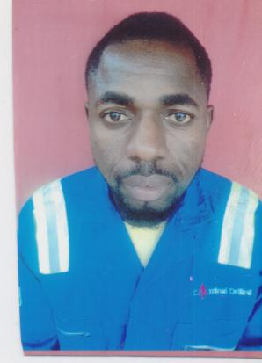
HAPPINESS OKON ASUQUO
Address: Flat 8, Alhaji Estate Close, Off Elitor Street, Woji Port Harcourt
Tel: 08035448819, 08099304272
Email: happinessasuquo@yahoo.com

PERSONAL DATA
DATE OF BIRTH: 14th February, 1987
SEX: Male
MARITAL STATUS: Married
NATIONALITY: Nigeria
STATE OF ORIGIN: Akwa Ibom
LOCAL GOVT. AREA: Uyo

EDUCATIONAL INSTITUTIONS ATENDED AND QUALIFICATION WITH DATES

- Methodist Primary School, Uyo (FSLC) 1990-1995
- Christian Community Secondary School (SSCE) 1996-2001

PROFESSIONAL QUALIFICATION

- Survival at sea and helicopter underwater Escape training 2013

WORK EXPERIENCE

TECON OIL SERVICE LTD
POSITION: Electrical/Rig Technician 2002-2013
[
JOB DESCRIPTION:
- Work as rig electrician on hydraulic work over unit 360k, 225k, 460k pulling capacity etc. Both locally and internationally Ghana, Congo (Loango platform offshore, Hauwa platform offshore, Mboundi onshore) and sheba offshore Nigeria.
- Repairs/replacement of electrical part on the rig and isolation of equipment for test maintenance purpose.
- General electrical repair of heavy duty truck, bulldozers, pay loaders, refrigerator and air conditioners
- Servicing and maintenance both for vehicle and industrial

CARDINAL DRILLING SERVICE NIG. LTD. 2013-till date
Position: Senior Technician

JOB DESCRIPTION

- Servicing of safety devices on crane e.g. load indicators,
Installing/servicing of car air condition etc
- Maintaining of kommey unit (accumulator) used in operating BOP (blowout preventers), pneumatic and electronic instrumentation
- Forklifts, crane installation and services.
- Repairs/replacement of electrical part on the rig and isolation of equipment for test maintenance purpose.
- Work as rig electrician on hydraulic work over unit 360k, 225k, 460k pulling capacity etc both locally and internationally Ghana, Congo (Loango platform offshore, Hauwa platform offshore, Mboundi onshore) and sheba offshore Nigeria.
- Perform daily task, Repair works, Breakdown equipment, Maintenance and other tasks.

COMPETENCES
- Knowledge of permit to work system, Job Hazard Analysis and emergency response plan
- Eight (8) years working experience
- Good team work
- Experience with hydraulic control system, high voltage switching, and electrical equipment in hazardous area.
- Highly skilled with computer and electrical equipment’s

HOBBIES
Football, Music and Travelling

REFEREES
- Mr. Luise Obi
(District Manager)
Tecon Oil Services Nig. Ltd.
08032767242

- Mr. Ifeanyi Peters
Tecon Oil Service Nig Ltd,
Trans Amadi PH
08136423863

- Mr. Joshua Oyema
Cardinal Drilling Services Nig. Ltd.
08033408183

