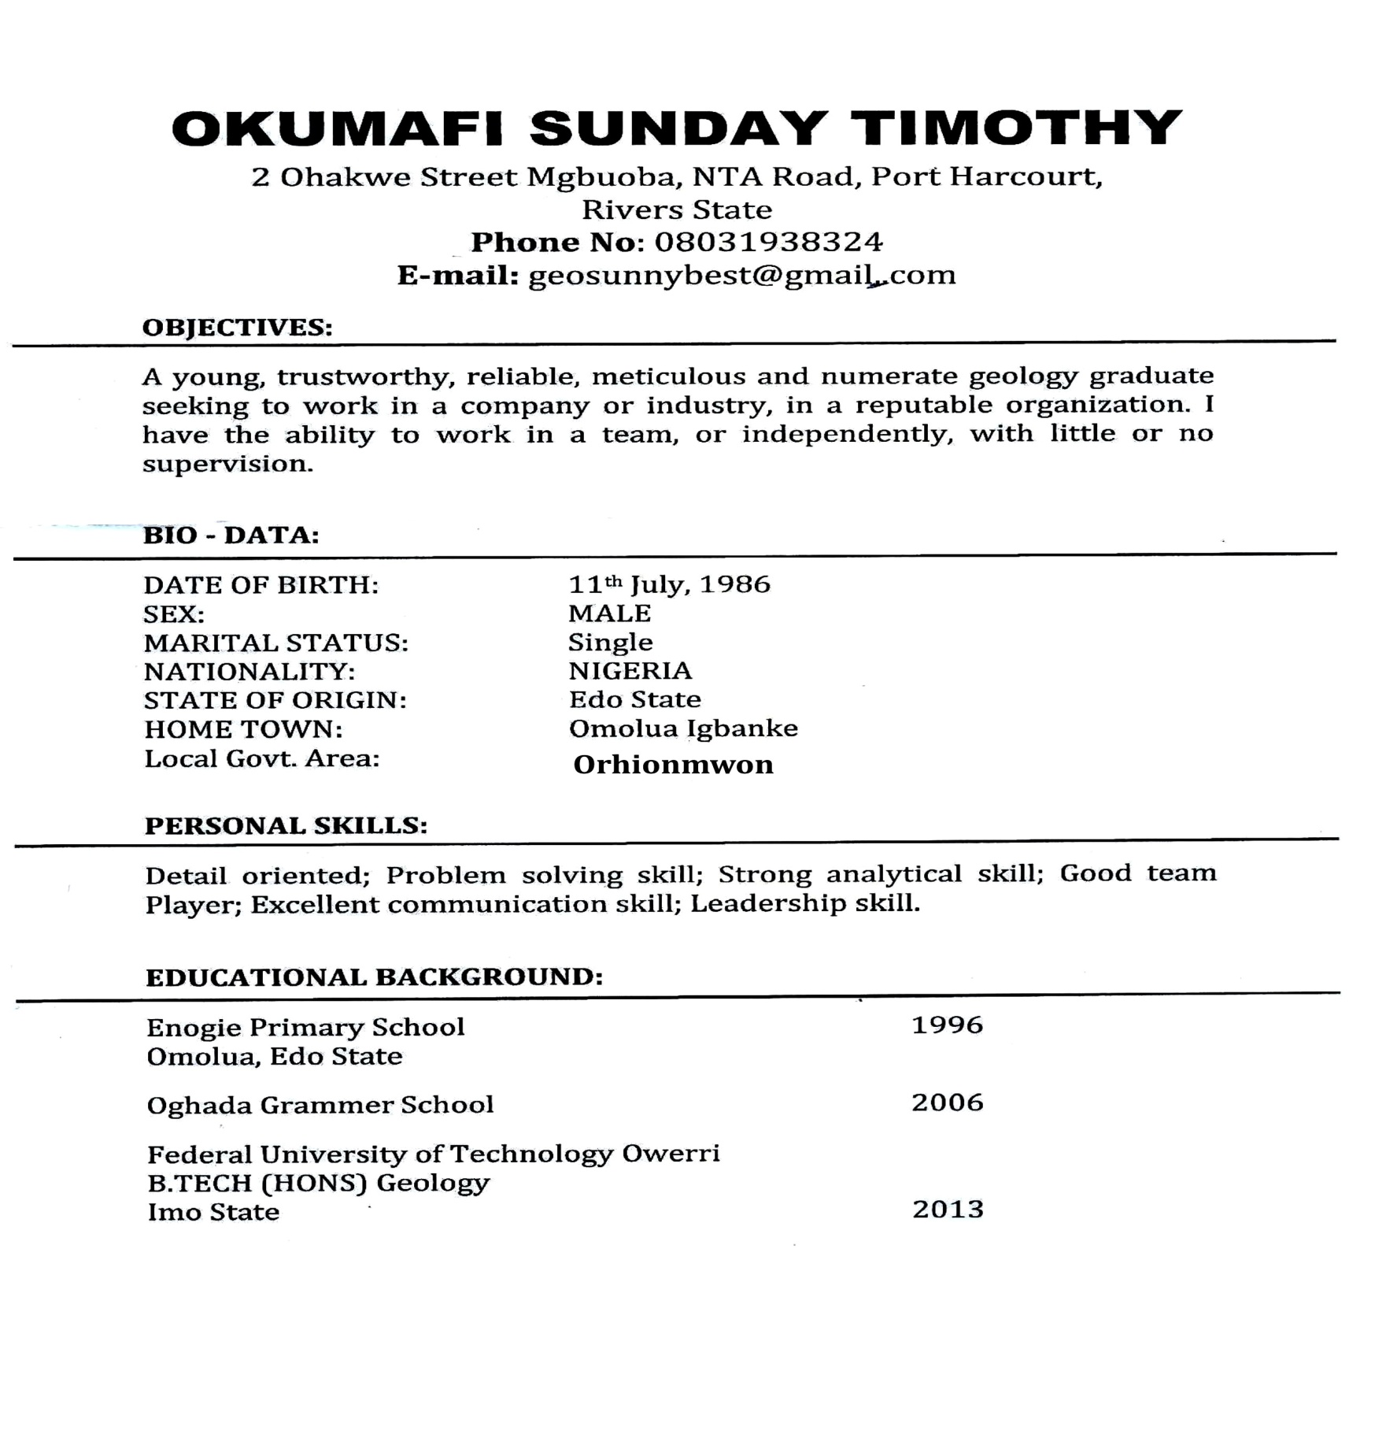
WORK EXPERIENCE
Bona Engineering Company 2014 – 2015
Benin-Agbor-Asaba Express Way
Behind Winners Church Agbor Obi
Worked as a Drilling Supervisor

REFEREES
Lucky Okumafi
Julius Ununamure and Company, Estate
Surveyors & Valuers, 226, Murtale
Muhummed Way,
Benin City.
08063275107, 08022755447

Engr. Okwubor John
PHCN Agbor,
Delta State
O8062549328

Engr. Jude IJieh
Atlantic Bluewater Services Ltd
(Engineering, Procurement & Maintenance Services)
Km 14 East-West /Uniport Road, Rumasi- Akpori, Port harcourt
07061528257

