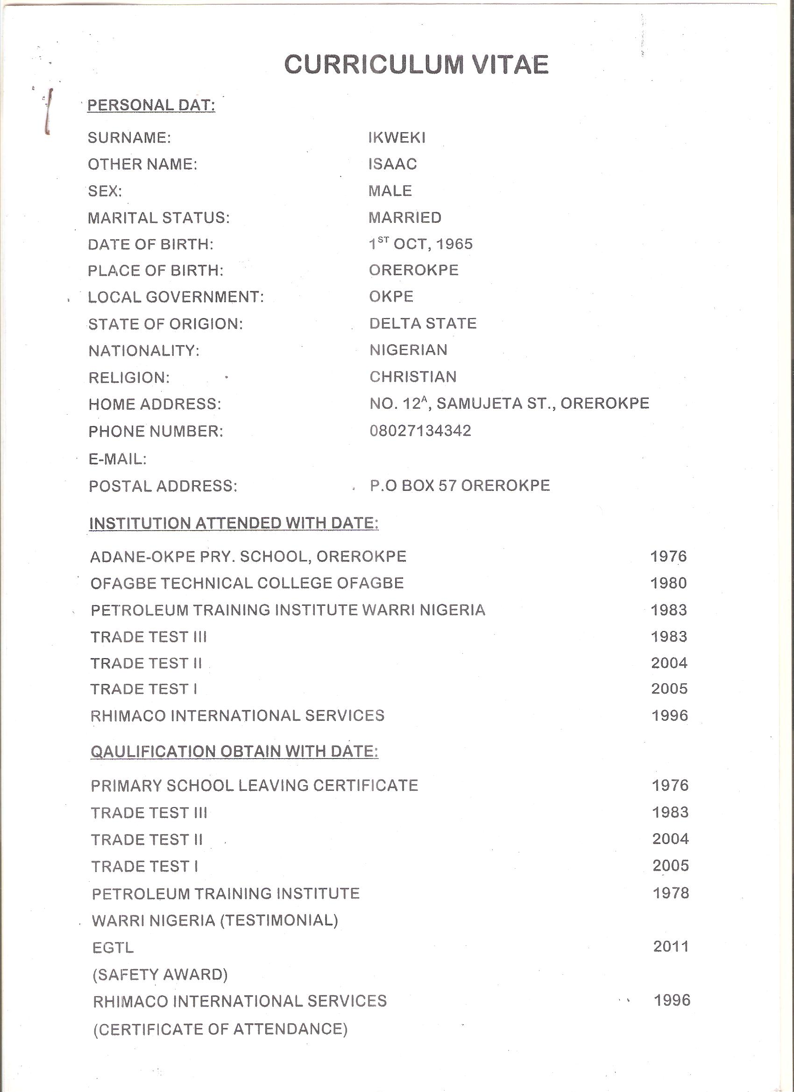
ESCARVOS GAS TO LIQUID (CHEVRON)

