IDENTITY CARD FORM
R


PASSPORT PHOTOGRAPH

Staff ID Card Number: S
Awobayo Ayokunle Joseph
NAME:

Surname First Name Others

Contact Centre Agent
POSITION:

Membership Unit
UNIT/BRANCH:

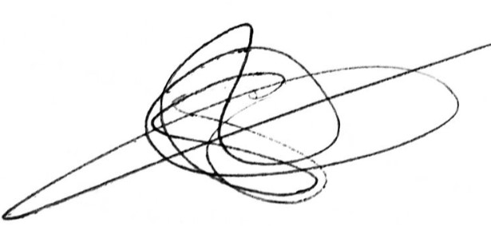

STAFF SIGNATURE:

AUTHORISATION:

This form must be returned with other completed documents for prompt processing please

